CREATE TABLE customer_info (

id_client INTEGER PRIMARY KEY,

total_amount NUMERIC,

gender VARCHAR(10),

age INTEGER,

count_city INTEGER,

response_comm BOOLEAN,

communication BOOLEAN,

tenure INTEGER

);

CREATE TABLE transactions_info (

date_new DATE,

id_check INTEGER,

id_client INTEGER,

count_products NUMERIC,

sum_payment NUMERIC,

FOREIGN KEY (id_client) REFERENCES customer_info(id_client)

);

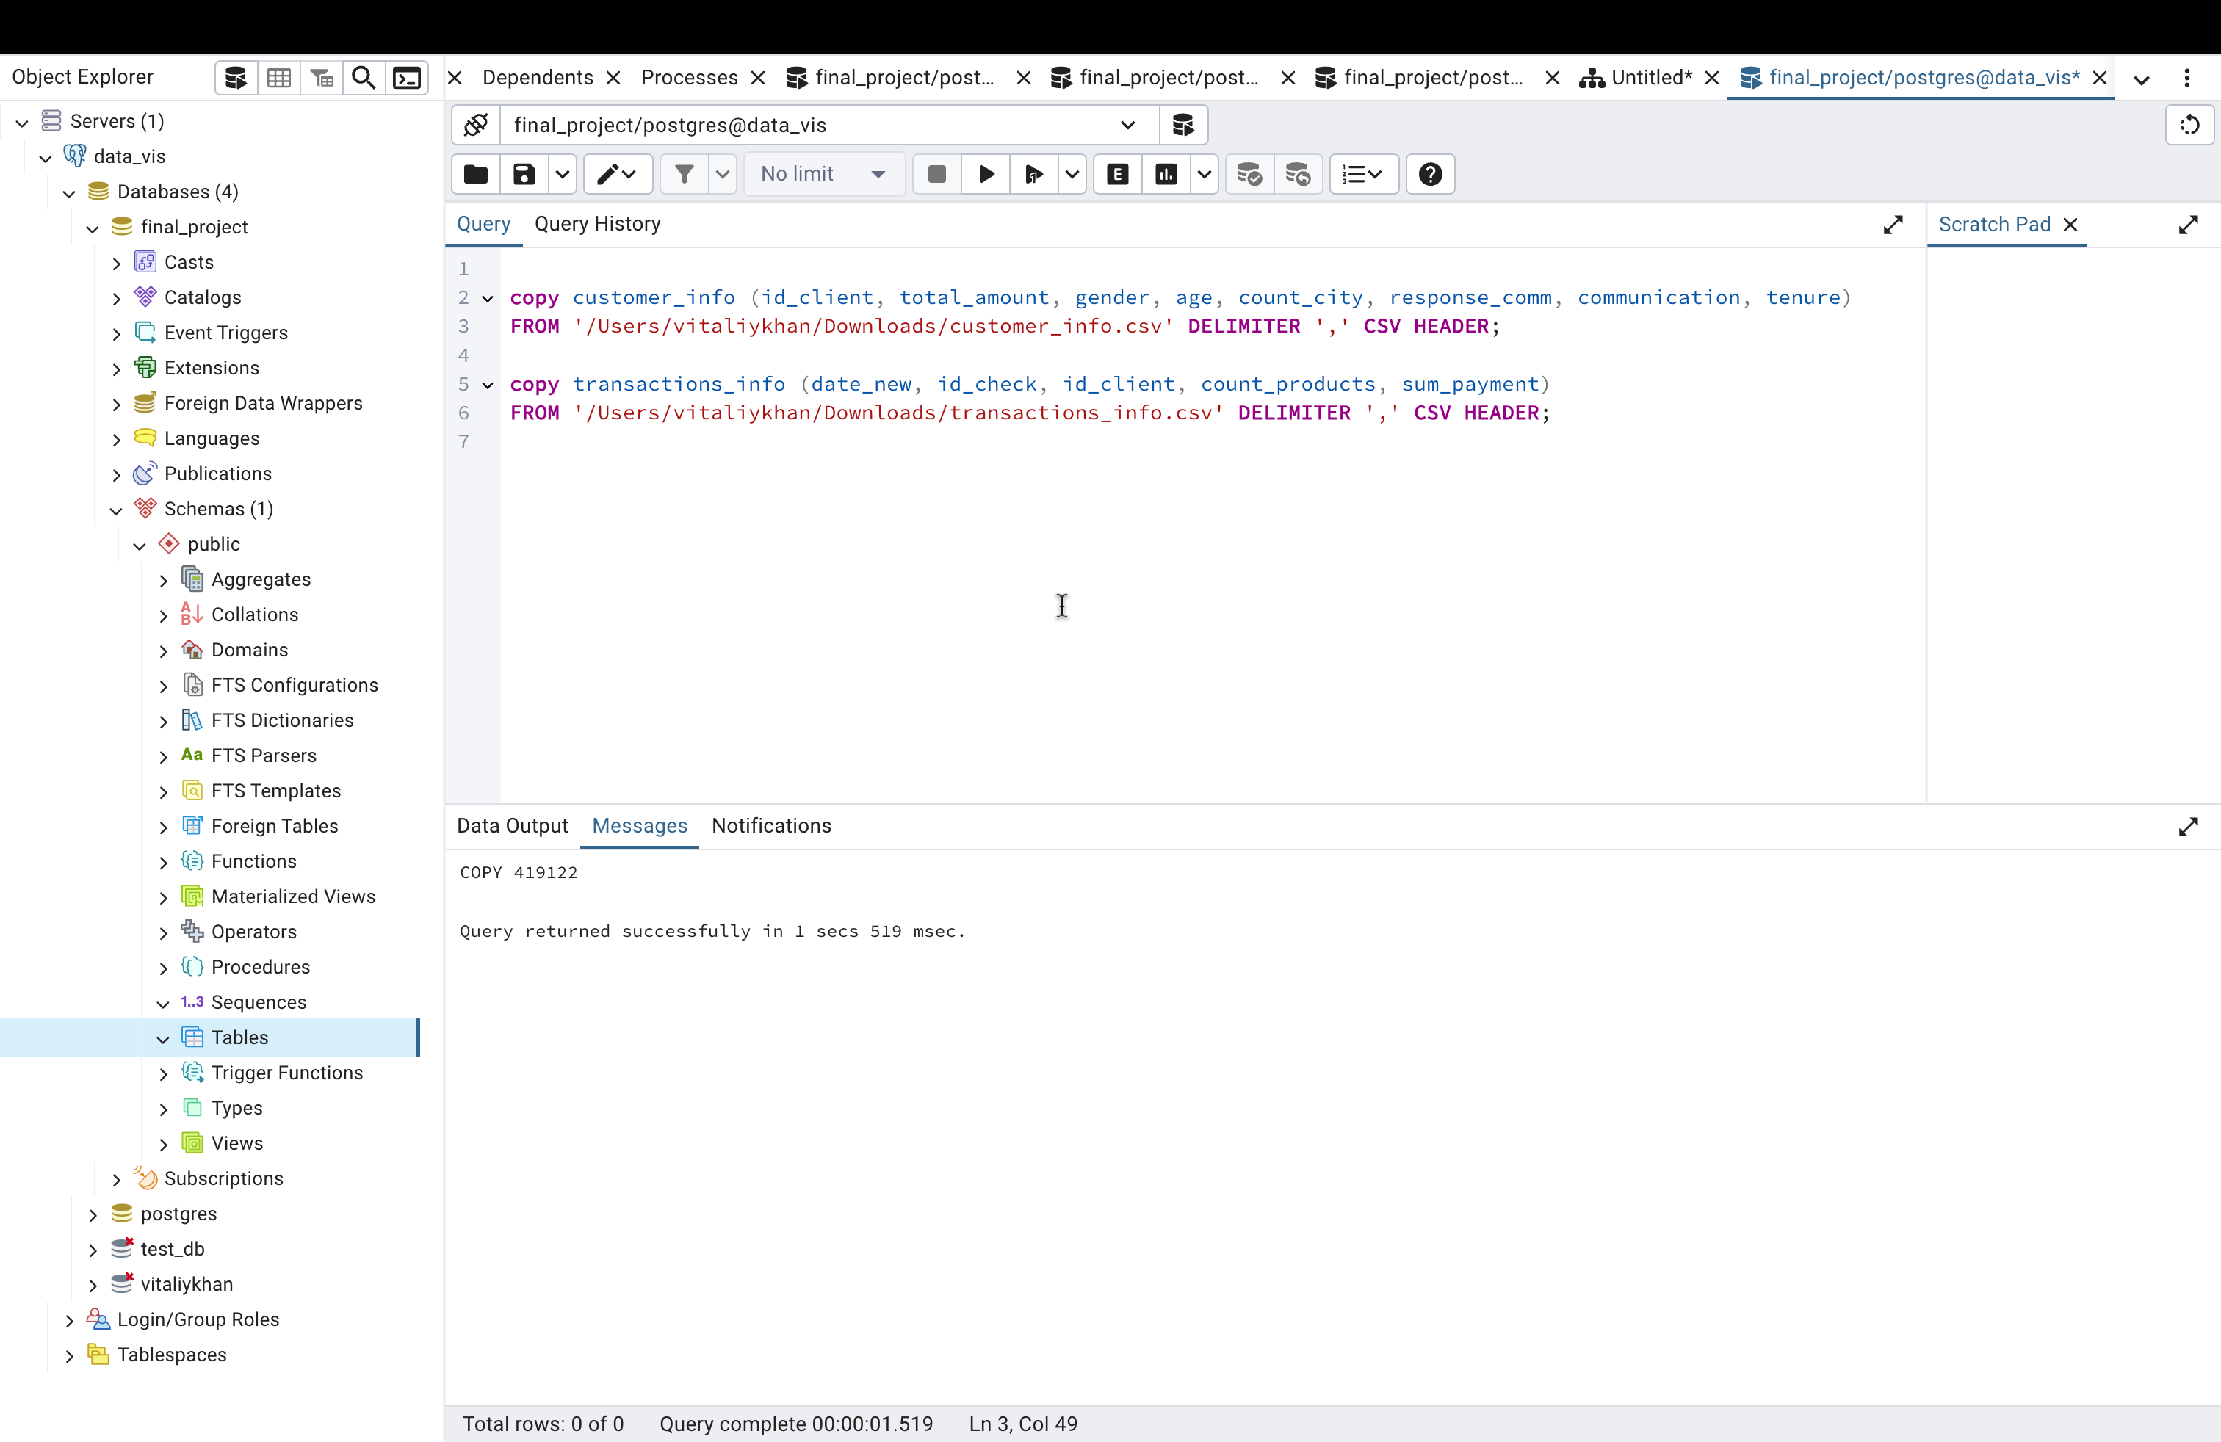

WITH monthly_activity AS (

SELECT id_client,

DATE_TRUNC('month', date_new) AS month

FROM transactions_info

WHERE date_new BETWEEN '2015-06-01' AND '2016-06-01'

GROUP BY id_client, month

),

client_activity AS (

SELECT id_client, COUNT(DISTINCT month) AS active_months

FROM monthly_activity

GROUP BY id_client

)

SELECT id_client

FROM client_activity

WHERE active_months = 12

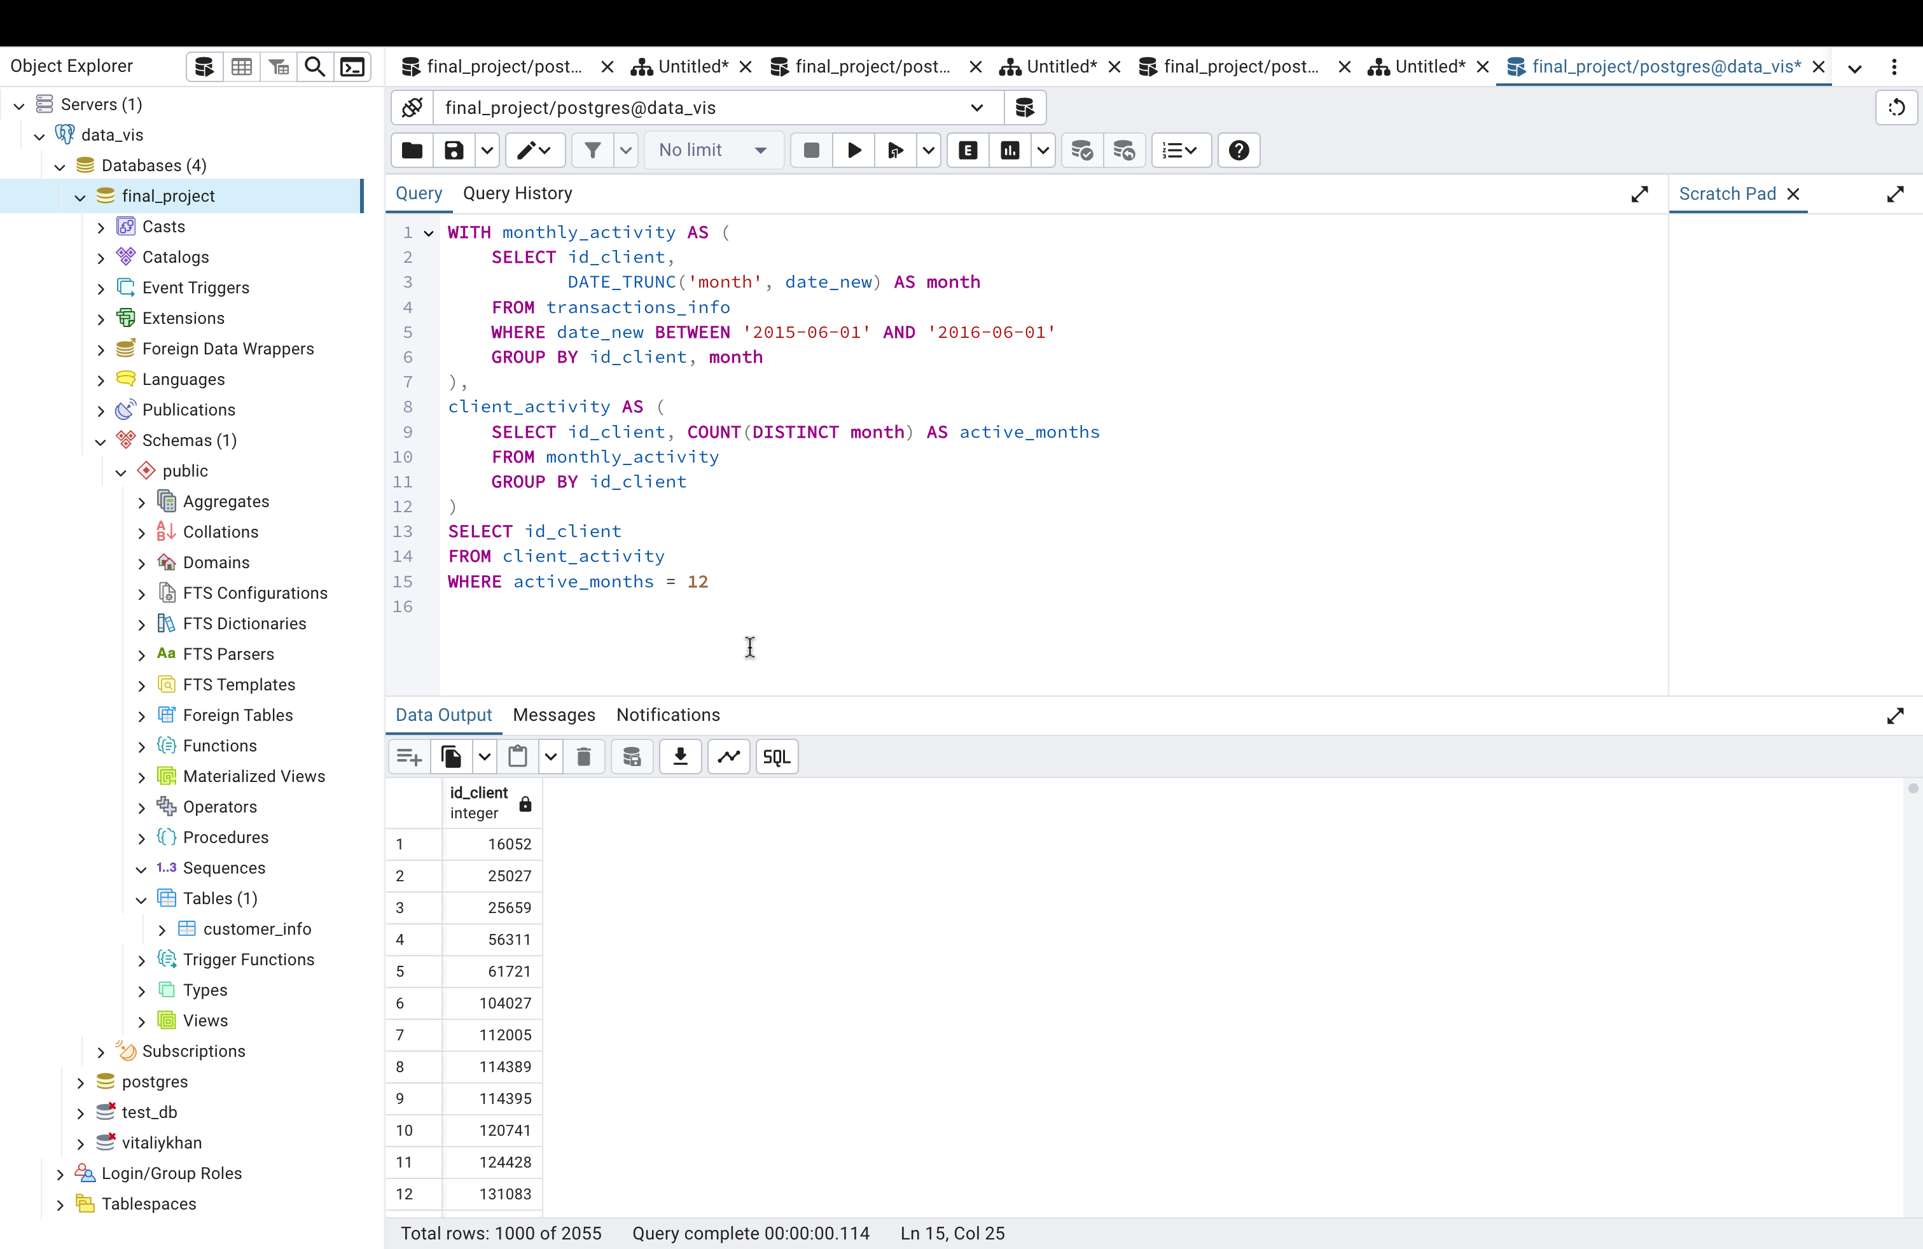

Average Amount of the Check Per Month

WITH monthly_summary AS (

SELECT

DATE_TRUNC('month', date_new) AS month,

SUM(sum_payment) AS total_amount,

COUNT(DISTINCT id_check) AS total_transactions

FROM

transactions_info

WHERE

date_new BETWEEN '2015-06-01' AND '2016-06-01'

GROUP BY

month

)

SELECT

month,

AVG(total_amount / NULLIF(total_transactions, 0)) AS avg_check_per_month

FROM

monthly_summary

GROUP BY

month

ORDER BY

month;

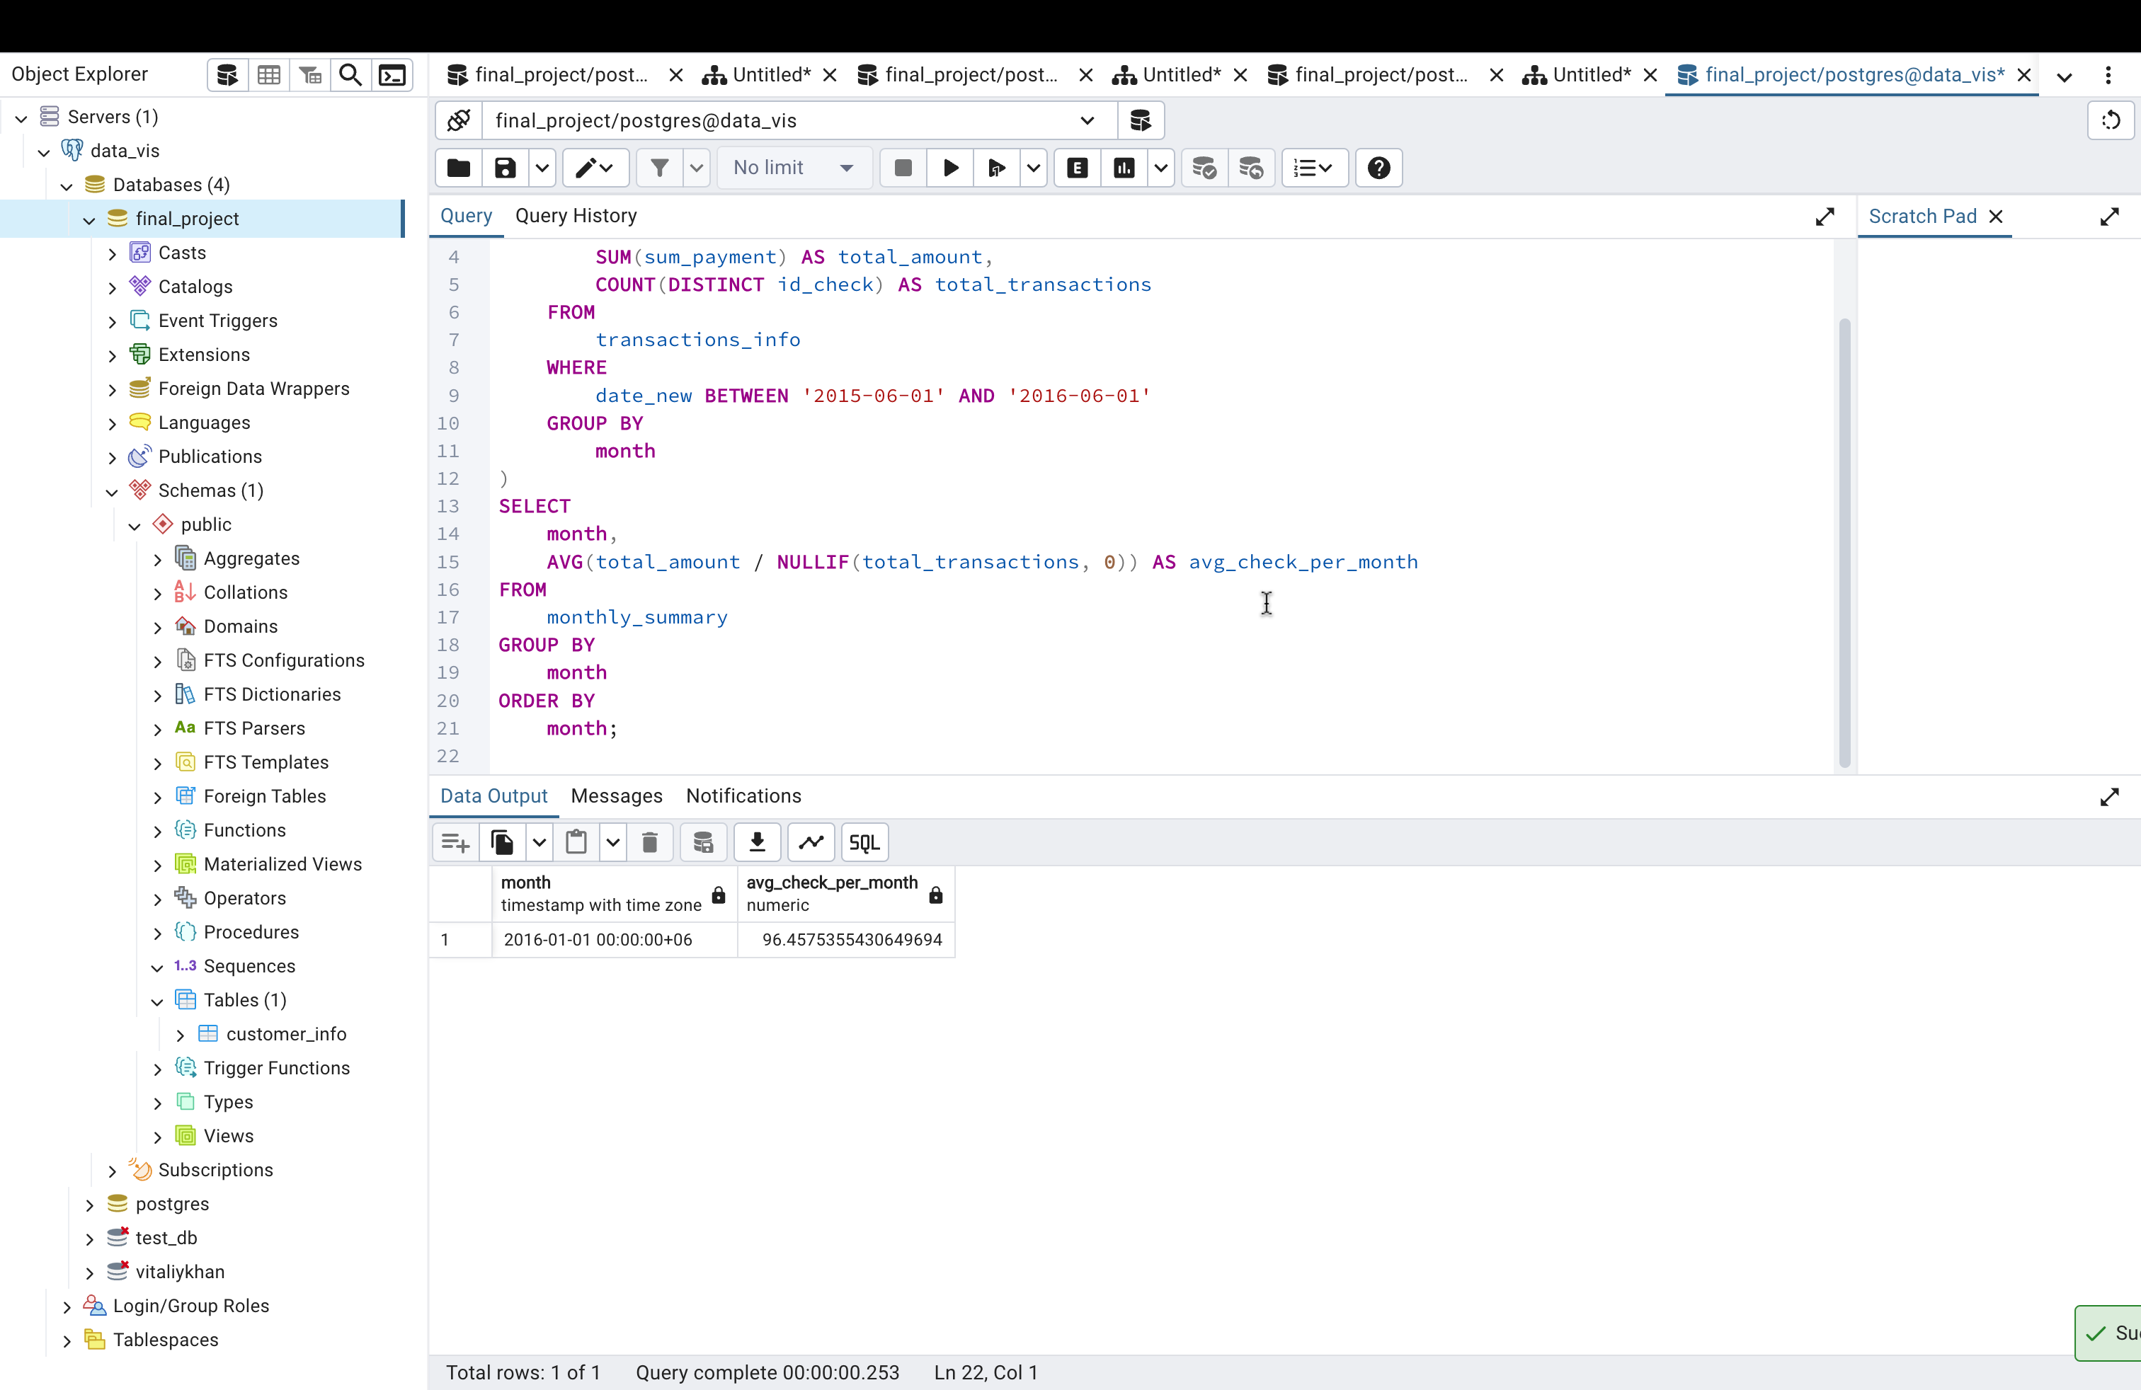

Average Number of Operations Per Month

WITH monthly_operations AS (

SELECT

DATE_TRUNC('month', date_new) AS month,

COUNT(id_check) AS total_operations

FROM

transactions_info

WHERE

date_new BETWEEN '2015-06-01' AND '2016-06-01'

GROUP BY

month

)

SELECT

month,

AVG(total_operations) AS avg_operations_per_month

FROM

monthly_operations

GROUP BY

month

ORDER BY

month;

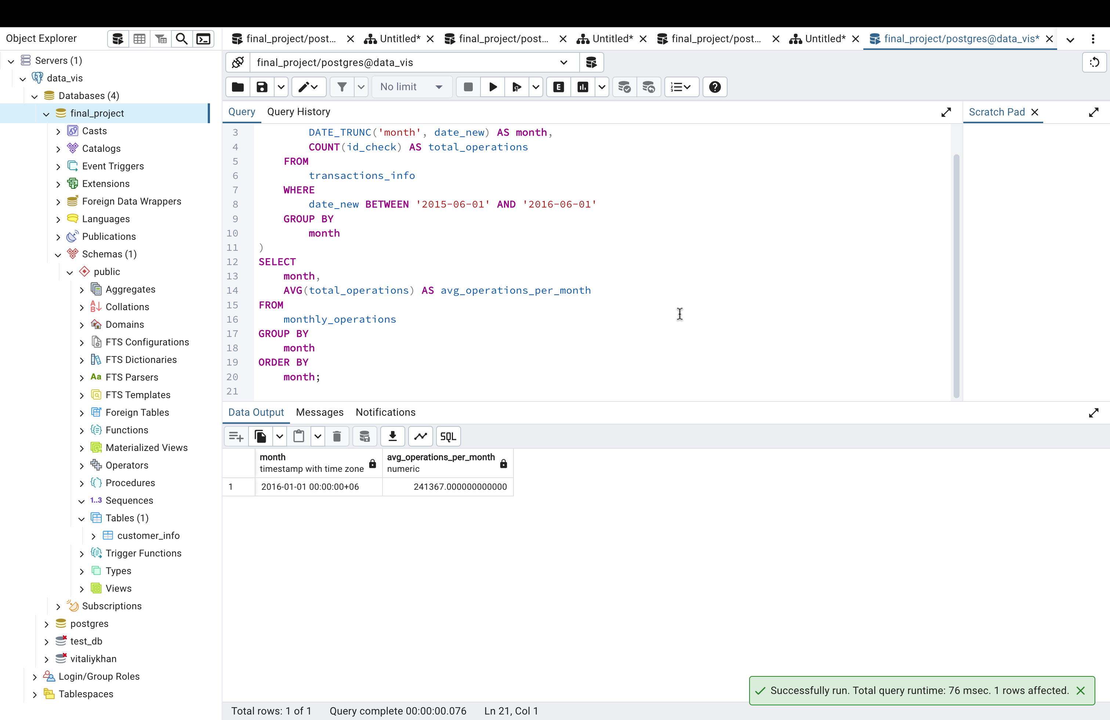

Average Number of Clients Who Performed Transactions Per Month

WITH monthly_clients AS (

SELECT

DATE_TRUNC('month', date_new) AS month,

COUNT(DISTINCT id_client) AS total_clients

FROM

transactions_info

WHERE

date_new BETWEEN '2015-06-01' AND '2016-06-01'

GROUP BY

month

)

SELECT

month,

AVG(total_clients) AS avg_clients_per_month

FROM

monthly_clients

GROUP BY

month

ORDER BY

month;

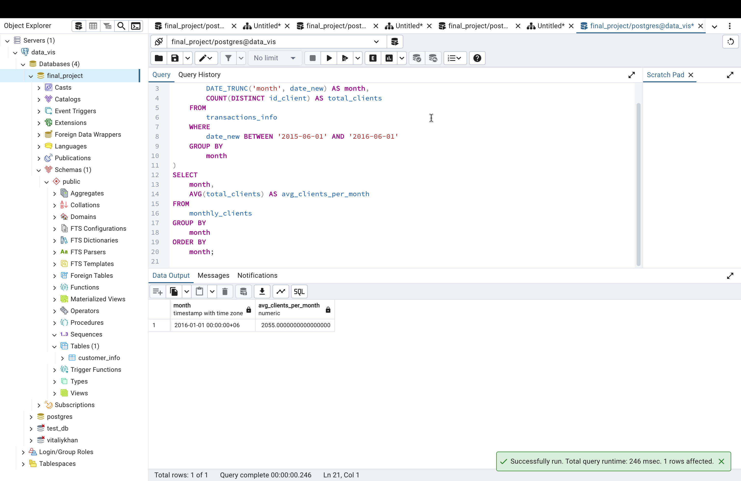

Share of Total Number of Transactions for the Year

WITH total_transactions AS (

SELECT

COUNT(id_check) AS total_year_transactions

FROM

transactions_info

WHERE

date_new BETWEEN '2015-06-01' AND '2016-06-01'

),

monthly_transactions AS (

SELECT

DATE_TRUNC('month', date_new) AS month,

COUNT(id_check) AS month_transactions

FROM

transactions_info

WHERE

date_new BETWEEN '2015-06-01' AND '2016-06-01'

GROUP BY

month

)

SELECT

mt.month,

mt.month_transactions,

(mt.month_transactions::decimal / NULLIF(tt.total_year_transactions, 0)) * 100 AS share_per_month

FROM

monthly_transactions mt

CROSS JOIN

total_transactions tt

ORDER BY

mt.month;

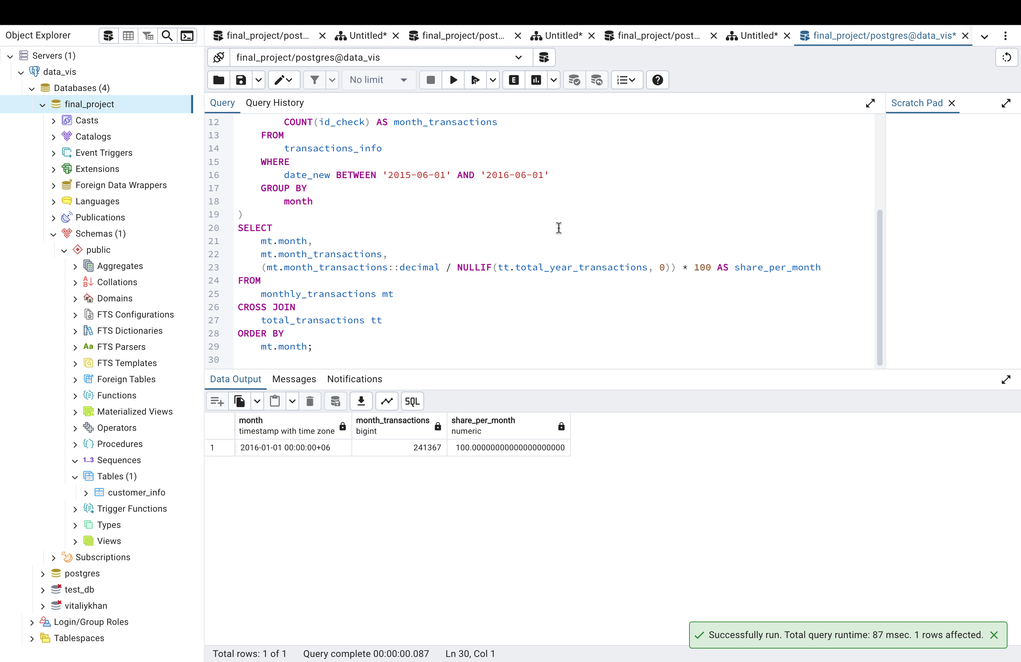

Print the % Ratio of M/F/NA in Each Month with Their Share of Costs

WITH monthly_gender_summary AS (

SELECT

DATE_TRUNC('month', ti.date_new) AS month,

SUM(CASE WHEN ci.gender = 'M' THEN ti.sum_payment ELSE 0 END) AS male_amount,

SUM(CASE WHEN ci.gender = 'F' THEN ti.sum_payment ELSE 0 END) AS female_amount,

SUM(CASE WHEN ci.gender IS NULL THEN ti.sum_payment ELSE 0 END) AS na_amount,

SUM(ti.sum_payment) AS total_amount

FROM

transactions_info ti

LEFT JOIN

customer_info ci ON ti.id_client = ci.id_client

WHERE

ti.date_new BETWEEN '2015-06-01' AND '2016-06-01'

GROUP BY

month

)

SELECT

month,

(male_amount / NULLIF(total_amount, 0)) * 100 AS male_share,

(female_amount / NULLIF(total_amount, 0)) * 100 AS female_share,

(na_amount / NULLIF(total_amount, 0)) * 100 AS na_share

FROM

monthly_gender_summary

ORDER BY

month;

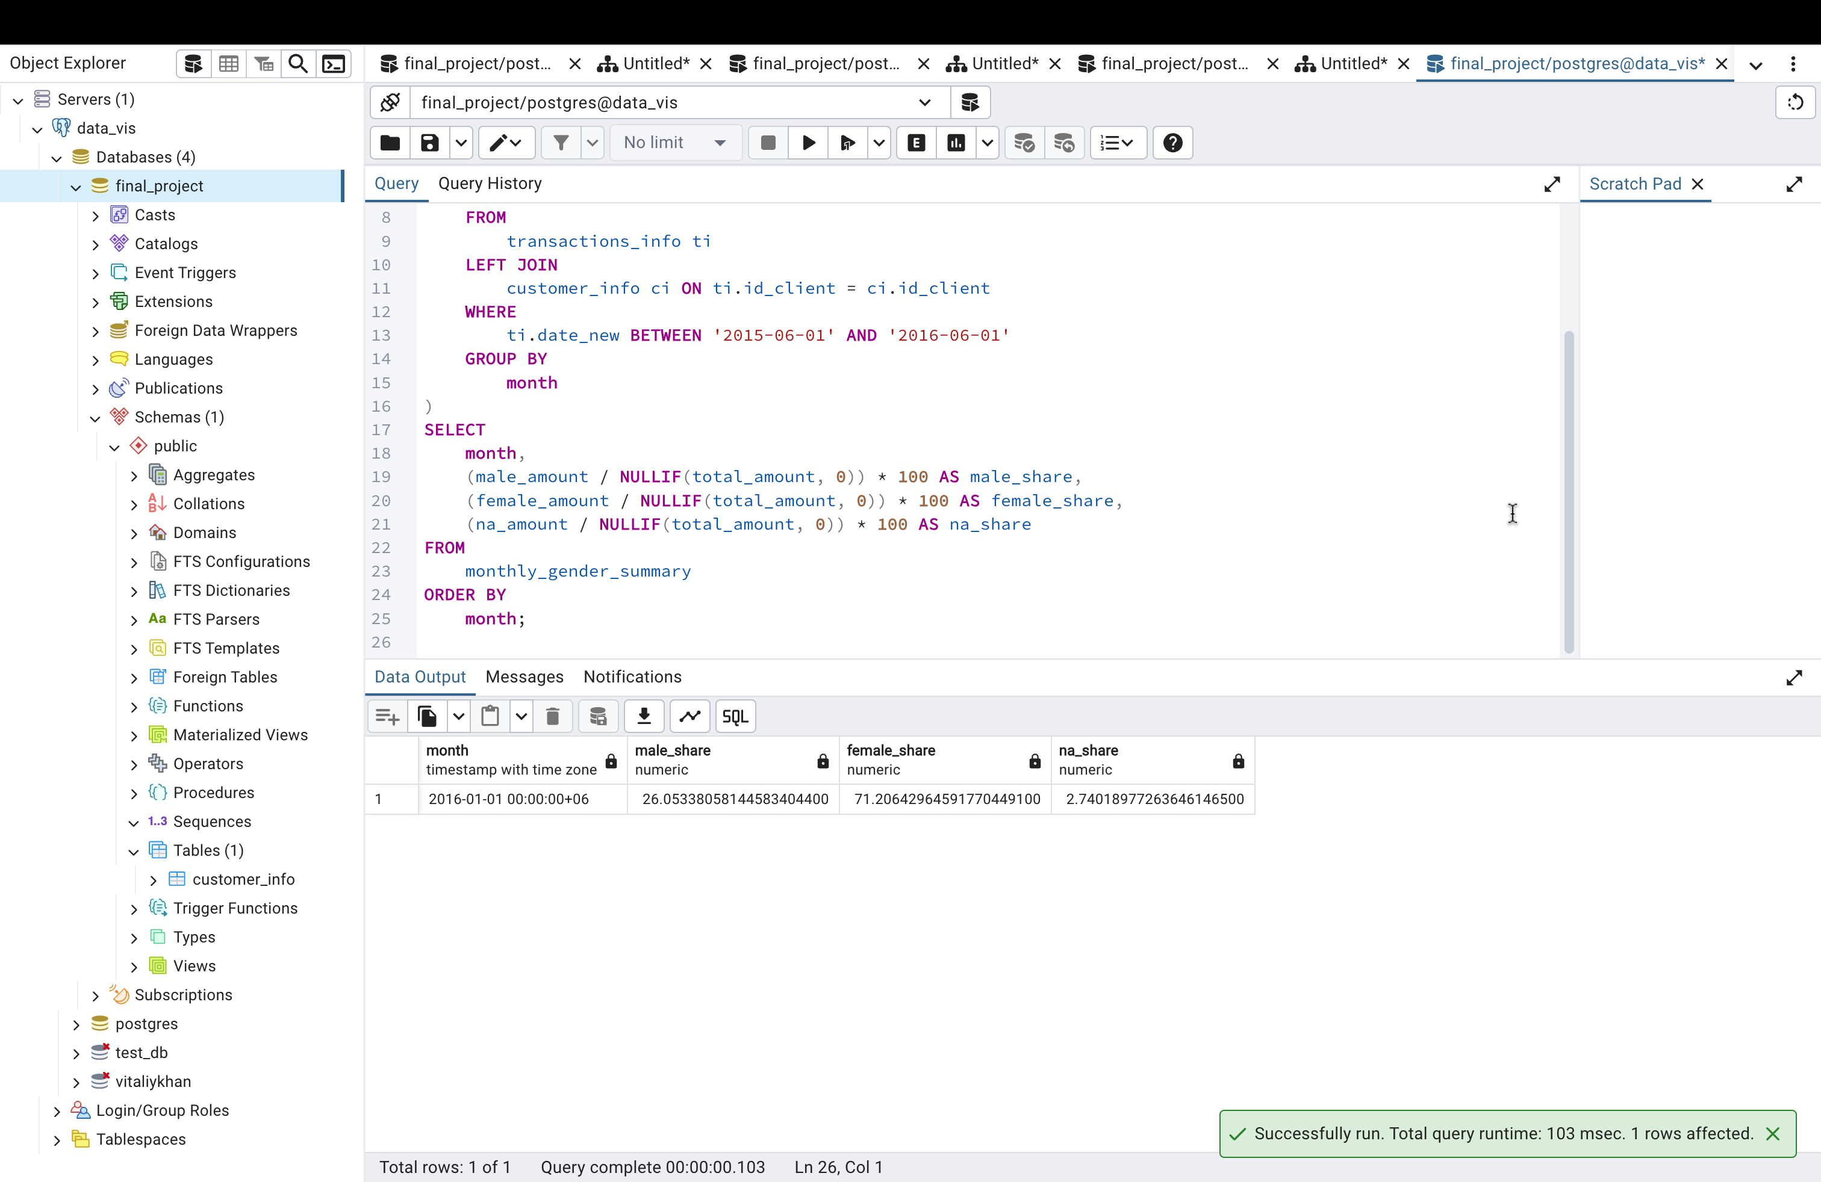

TASK3

Age Groups and Transactions for the Entire Period

WITH age_group_summary AS (

SELECT

CASE

WHEN ci.age IS NULL THEN 'Unknown'

WHEN ci.age BETWEEN 0 AND 9 THEN '0-9'

WHEN ci.age BETWEEN 10 AND 19 THEN '10-19'

WHEN ci.age BETWEEN 20 AND 29 THEN '20-29'

WHEN ci.age BETWEEN 30 AND 39 THEN '30-39'

WHEN ci.age BETWEEN 40 AND 49 THEN '40-49'

WHEN ci.age BETWEEN 50 AND 59 THEN '50-59'

WHEN ci.age BETWEEN 60 AND 69 THEN '60-69'

WHEN ci.age BETWEEN 70 AND 79 THEN '70-79'

WHEN ci.age >= 80 THEN '80+'

END AS age_group,

SUM(ti.sum_payment) AS total_amount,

COUNT(ti.id_check) AS total_transactions

FROM

transactions_info ti

LEFT JOIN

customer_info ci ON ti.id_client = ci.id_client

WHERE

ti.date_new BETWEEN '2015-06-01' AND '2016-06-01'

GROUP BY

age_group

)

SELECT

age_group,

total_amount,

total_transactions

FROM

age_group_summary

ORDER BY

age_group;

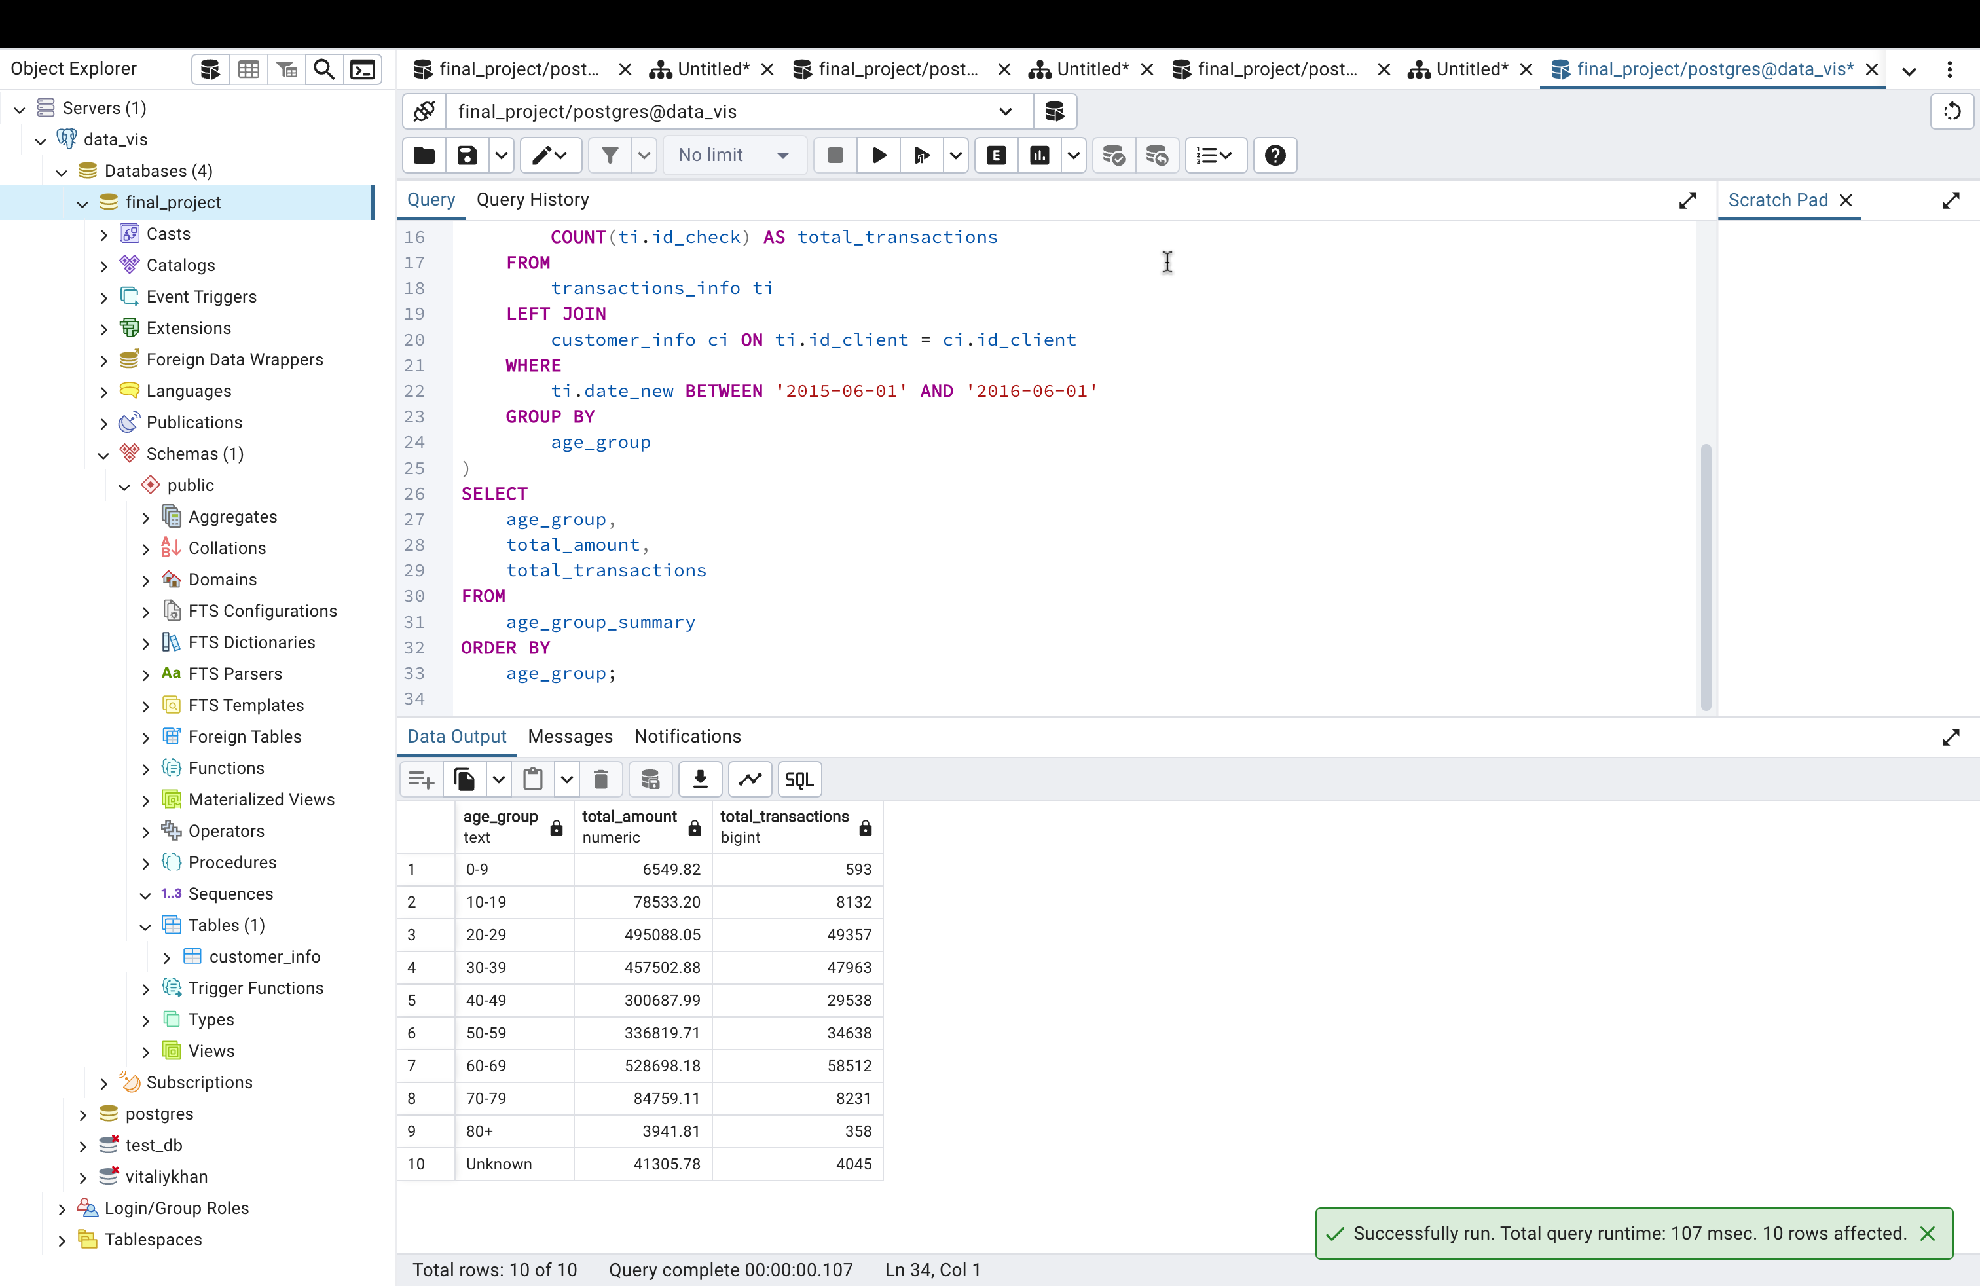

Quarterly Averages and Percentages

WITH quarterly_age_group_summary AS (

SELECT

CASE

WHEN ci.age IS NULL THEN 'Unknown'

WHEN ci.age BETWEEN 0 AND 9 THEN '0-9'

WHEN ci.age BETWEEN 10 AND 19 THEN '10-19'

WHEN ci.age BETWEEN 20 AND 29 THEN '20-29'

WHEN ci.age BETWEEN 30 AND 39 THEN '30-39'

WHEN ci.age BETWEEN 40 AND 49 THEN '40-49'

WHEN ci.age BETWEEN 50 AND 59 THEN '50-59'

WHEN ci.age BETWEEN 60 AND 69 THEN '60-69'

WHEN ci.age BETWEEN 70 AND 79 THEN '70-79'

WHEN ci.age >= 80 THEN '80+'

END AS age_group,

DATE_TRUNC('quarter', ti.date_new) AS quarter,

SUM(ti.sum_payment) AS total_amount,

COUNT(ti.id_check) AS total_transactions

FROM

transactions_info ti

LEFT JOIN

customer_info ci ON ti.id_client = ci.id_client

WHERE

ti.date_new BETWEEN '2015-06-01' AND '2016-06-01'

GROUP BY

age_group, quarter

)

SELECT

age_group,

quarter,

AVG(total_amount) AS avg_amount_per_quarter,

AVG(total_transactions) AS avg_transactions_per_quarter,

ROUND(100.0 * SUM(total_amount) / (SELECT SUM(ti.sum_payment) FROM transactions_info ti WHERE ti.date_new BETWEEN '2015-06-01' AND '2016-06-01'), 2) AS percent_amount,

ROUND(100.0 * SUM(total_transactions) / (SELECT COUNT(ti.id_check) FROM transactions_info ti WHERE ti.date_new BETWEEN '2015-06-01' AND '2016-06-01'), 2) AS percent_transactions

FROM

quarterly_age_group_summary

GROUP BY

age_group, quarter

ORDER BY

age_group, quarter;

